**Chess for Beginners: A Guide to Learning the main openings.**

Presentation Summary: In this Python program, we have implemented a chess-related application that allows users to sign up, log in, learn chess moves, and retrieve their information. The program utilizes various functions for input validation and data management. It also includes a database to store user information and track chess moves.

**Introduction**

Chess, often considered the "game of kings," captivates our minds with its strategic depth and countless possibilities. However, for beginners, navigating the vast landscape of chess openings can be daunting. Recognizing this challenge, we have developed a purpose-driven program that aims to empower aspiring players by providing them with a solid foundation in both black and white openings.

In this Python program, we have implemented a chess-related application that allows users to sign up, log in, learn chess moves, and retrieve their information. The program utilizes various functions for input validation and data management. It also includes a database to store user information and track chess moves.

libraries used: numpy and pandas.



**User Sign-up**

* The code initializes an empty list called users to store user information and creates empty lists for different user attributes such as names, ages, IDs, and genders.
* The names() function is defined to prompt the user to enter their first name and last name. It validates that the names contain only letters and returns the full name.
* The ages() function is defined to prompt the user to enter their age. It checks if the input consists only of digits and returns the age.
* The genders () function is defined to prompt the user to enter their gender as "male" or "female." It validates the input and returns the gender.
* The passwords () function is defined to prompt the user to enter a password. It checks if the password meets the required criteria (at least 8 characters, letters, at least 1 special character, and at least one number) and returns the password.
* The code enters a loop where the user can choose between signing up and logging in.
* If the user chooses to sign up (option 1), the code calls the names(), ages(), genders(), and passwords() functions to collect the user's information.
* An ID number is assigned to the user, starting from 0 and incrementing by 1 for each new user.
* The user's information is stored in the users list as a sublist containing the name, age, gender, password, and ID.
* The user's information is also added to respective lists (namesus, agesus, gendersus, IDsus) to maintain separate lists for each attribute.
* The user is provided with their ID number, which they need to remember for logging in.
* The loop continues, allowing the user to choose between signing up and logging in again.

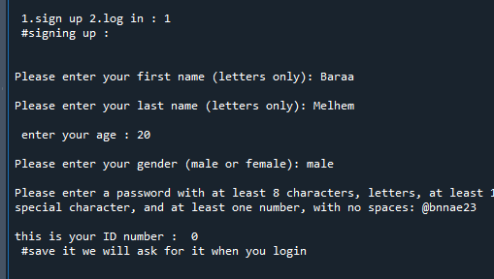

**User Log-in**

* The code would prompt the user to enter their ID number, which they obtained during the sign-up process.
* The user would input their ID number.
* The code would search for the ID number in the IDsus list to check if it exists.
* If the ID number is found, the code would prompt the user to enter their password.
* The user would input their password.
* The code would compare the entered password with the stored password associated with the user's ID number in the users list.
* If the entered password matches the stored password, the code would display a message indicating successful sign-in.
* If the entered password does not match the stored password, the code would display an error message indicating incorrect password.
* If the ID number is not found in the IDsus list, the code would display an error message indicating that the user does not exist.

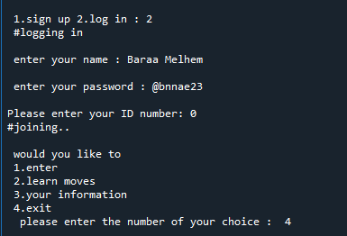

**Admin Log-in**

Sign-In Process for Admin:

The first admin in the list is admin1, with the password @jqhq21ll1 , # number 15633 and ID 0.

﻿

1. Admin Sign-In:
   * When choosing the login option, the user is prompted to enter their name, password, # number, and ID.
   * The entered credentials are then checked against the admin credentials in the "Admins" list.
2. Admin Powers:
   * Once the admin successfully logs in, they gain access to additional functionality.
   * the admin's primary power is the ability to add other admins.
   * The admin can add other admins by appending their credentials to the "Admins" list, and access to user's information.

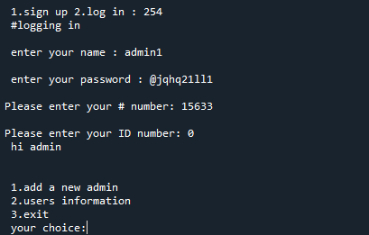

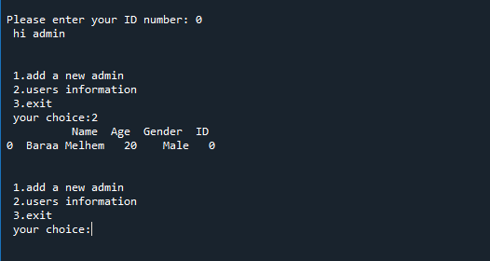

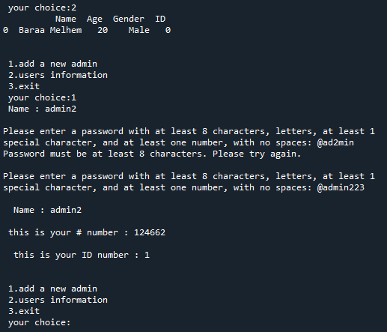

**Chess Moves**

In the given code, the functionality of entering chess moves allows users to input moves for both white and black pieces in a chess game. Here's how users can input white and black moves:

1. For white moves:
   * The code prompts the user to enter a move for the white player.
   * The user can input the move in algebraic notation, such as "e4" or "Nf3", etc...
   * The entered move is then appended to the white_moves list, which stores all the moves made by the white player.
2. For black moves:
   * Similarly, the code prompts the user to enter a move for the black player.
   * The user can input the move in the same algebraic notation as for white moves.
   * The entered move is appended to the black_moves list, which stores all the moves made by the black player.

The white_moves and black_moves lists serve as repositories for storing the moves made by the white and black players, respectively. These lists can be accessed and utilized throughout the code to track the progress of the game or validate moves.

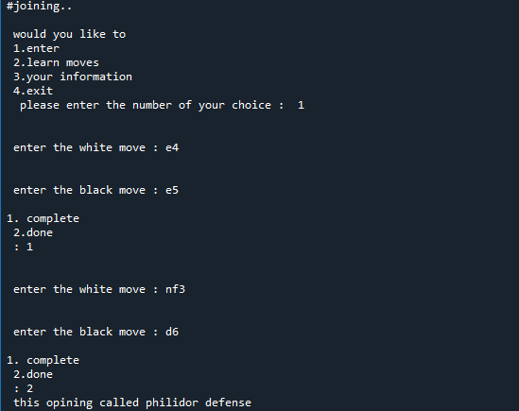

**Learning Moves**

﻿

1. Language Selection:
   * The code prompts the user to select a language to receive information about chess moves.
2. Available Options:
   * After selecting the language, the code provides a menu of available options for the user to choose from.
   * These options typically include learning about defenses and openings, but may include additional chess-related topics.
3. Information on Defenses and Openings:
   * Once the user selects a specific option, such as learning about defenses or openings, the code provides relevant information based on the user's choice.
   * This information can be retrieved from a pre-defined database or knowledge base that contains details about various defenses, openings, and other chess-related concepts.
   * The code may utilize conditional statements or functions to retrieve and display the appropriate information based on the user's input.

For example, if a user selects the option to learn about defenses, the code might retrieve information about common defensive strategies in chess, such as the Sicilian Defense or the French Defense. The code can then present this information to the user in the selected language.

Similarly, if the user selects the option to learn about openings, the code can provide information about popular chess openings like the Queen's Gambit or the Ruy Lopez, including their key moves and strategic considerations.

The code's functionality to provide information on defenses and openings based on user input relies on a combination of user selection, database retrieval, and appropriate language presentation. By incorporating a knowledge base of chess concepts, the code can offer users the opportunity to learn more about specific aspects of the game and enhance their understanding of various strategies and techniques.

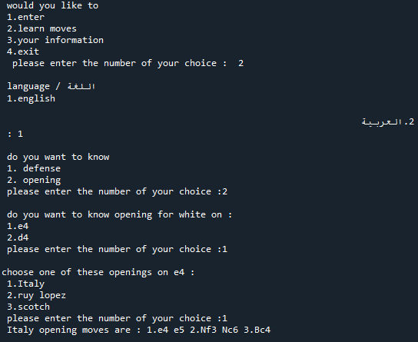

**Conclusion**

1. Sign-up and Sign-in:

- Users can sign up by providing a username and password.

- Users can sign in with their registered username, password and ID.

﻿

2. Chess Move Input:

- Users can input chess moves by specifying the starting and ending positions of the pieces.

- The moves are stored in separate lists for white moves and black moves.

﻿

3. Learning about Chess Moves:

- Users can select a language to receive information about chess moves.

- They can choose from a menu of options, such as learning about defenses or openings.

﻿  
﻿

Al-Baraa Ibrahim Melhem

Phone number: +962772559564

Gmail : [baraaibramelhem@gmail.com](mailto:baraaibramelhem@gmail.com)

Linkedin : <https://www.linkedin.com/in/baraa-melhem-17837a257/.com/i-melhem>

-17837a257

